Automated Vehicle Number Plate Recognition using MATLAB

Mantej Singh1, Anubhav Tuknayat2, Tanzeel Ur Rehman3, Harshveer Singh4, Agampreet Singh5, Sayamvir Singh6 and Anubhav Kumar7

*1,2,3,4,5,6,7(2nd Year UG Students, ECE Department, Punjab Engineering College, Chandigarh, India)*

***Abstract- In this paper a method for the recognition of vehicle registration numbers from number plates, entering them in a database and controlling a boom barrier based security system is proposed. The concept of template matching has been used for the recognition of characters from the number plate. In this method firstly the image is taken as an input, then a number of pre-processing steps such as conversion to grayscale, binarizing the image and Prewitt edge-detection are applied on the image by the use of pre-defined functions in MATLAB to make the image more suitable for letter recognition. After this, the location of the number plate in the entire input image is detected. This number plate is later cropped out from the input image and unnecessary objects are removed from the image. Finally, each character in the number plate is segmented. Segmentation is done on the basis of connected components. Then after segmentation, recognition of characters is done by matching the templates to the segmented characters. Matching is done on the basis of correlation between the detected characters and the templates stored in the database. In the last step, an MS Excel sheet is created which collects all the numbers, their date & time of entry and if they were granted access or not. Consequently, a boom barrier is given a command to open or stay closed depending on whether the number was found in the database. Simulation of the project is done in MATLAB.***

I. INTRODUCTION

Today, every country has a well-defined system for vehicle registration and the authorization of registration numbers to each vehicle. The registration identifier is a numeric or alphanumeric ID that [uniquely identifies](https://en.wikipedia.org/wiki/Unique_identifier) the vehicle or vehicle owner within the issuing region's [vehicle register](https://en.wikipedia.org/wiki/Vehicle_register). In some countries, the identifier is unique within the entire country, while in others it is unique within a state or province. This registration number is usually displayed on a plate, generally made of aluminium. Plates are usually fixed directly to a vehicle or to a plate frame that is fixed to the vehicle. Sometimes, the plate frames contain advertisements or graphics inserted by the vehicle service centre or the dealership from which the vehicle was purchased.

The detection of this number is beneficial for numerous purposes, such as security systems, traffic management, automatic parking systems or tracking of stolen cars. At workspaces of many companies, number plate recognition has been incorporated to grant access only to vehicles of authorized personnel. This is achieved through an ANPR (Automated Number Plate Recognition) system.

Stages of a General ANPR system:

Reading Input Image

Pre-Processing

Character Segmentation

Character Recognition

Displaying Characters

**Fig.1:** Stages of a General ANPR system

1.1 OVERVIEW

The concept of Automatic Number Plate Recognition can be applied at various commercial places such as, shopping malls and traffic stops.

Firstly, the vehicle will stop at the barrier gate, where an installed camera would take a snapshot of the front view of the vehicle, consisting of the number plate. This scanned image would be sent into the system for processing. The system will apply certain operations to locate the number plate position and extract the characters. Once the processes are complete and the number has been recognized, the system will match the detected number in the registered database to check whether the vehicle has been registered or not. If the number is found, access for entrance is provided and the barrier is opened, otherwise the barrier remains closed and an appropriate message is displayed.

Boom-Barrier (Open or Closed)

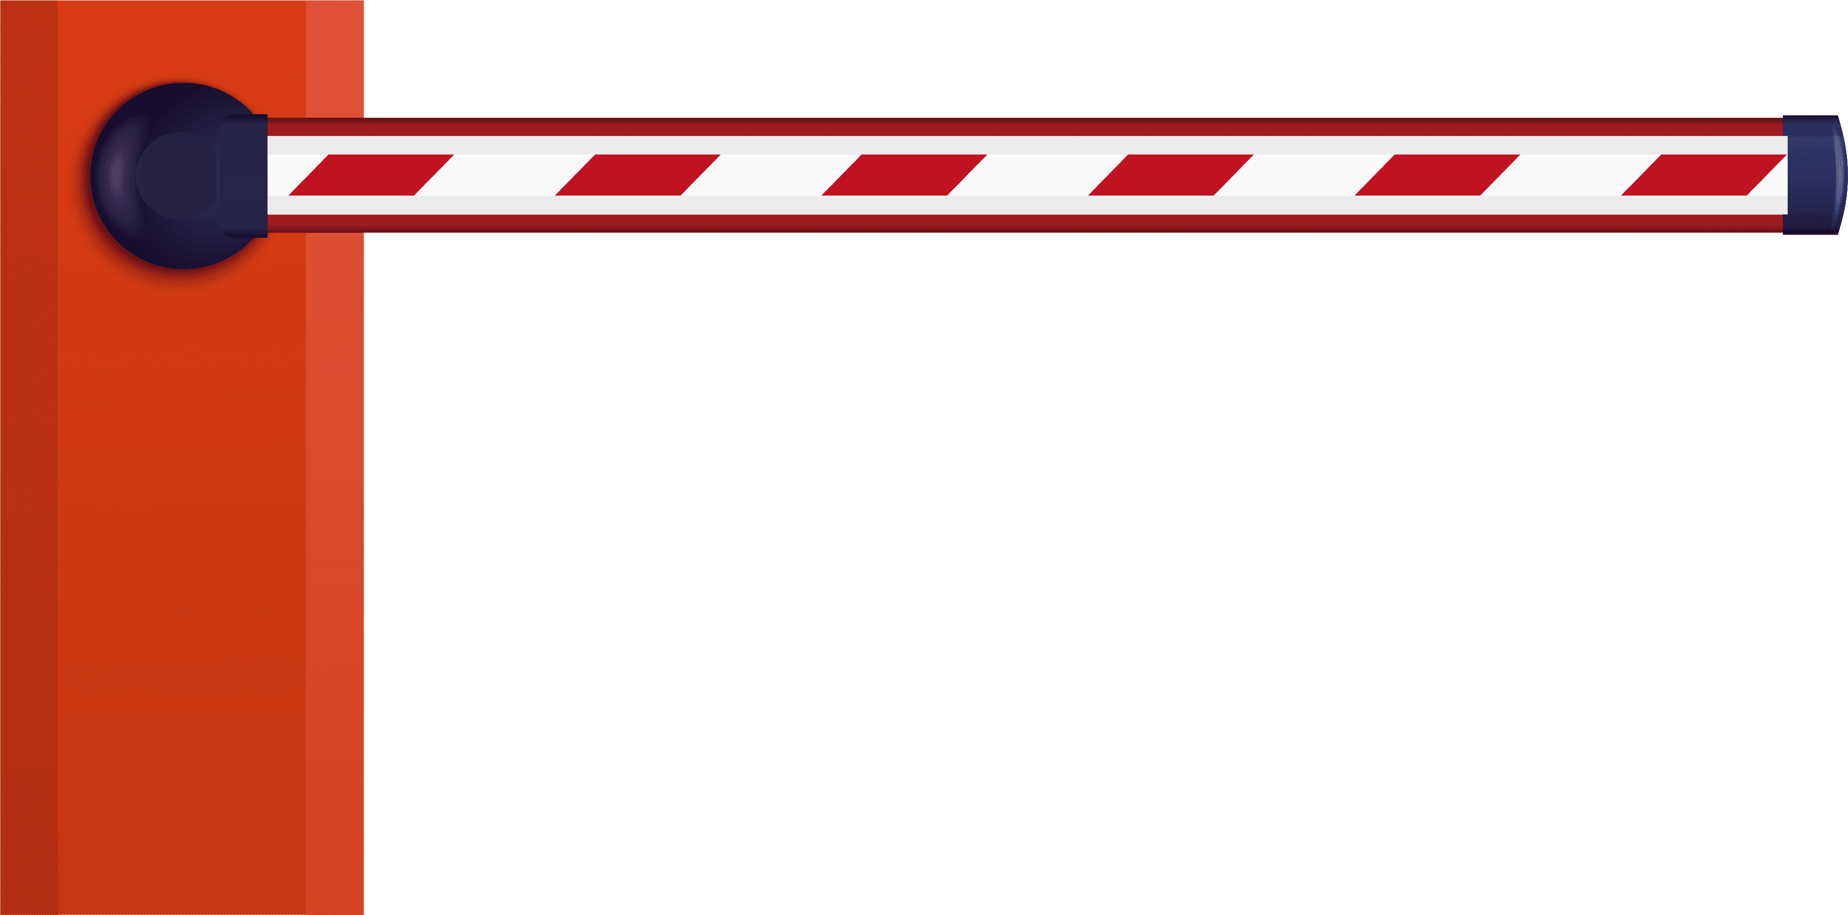



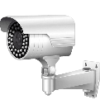

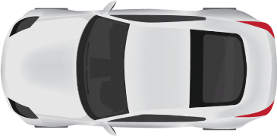

System with MATLAB installed

* Reading the image
* Comparing with templates stored in database
* Display result and give command to barrier

**Fig. 2:** Block Diagram of the security system

Also, the efficiency and accuracy of the recognition system depends on various factors such as the speed of vehicle, weather conditions, type of vehicle (different vehicles would have different number plate placement), type of number plate and the font used on the number plate.

1.2 OBJECTIVE

The overall objective of the project is to develop a system that recognizes the number from a vehicle number plate from a car at a gate entrance of a parking area or any other security area in general. The software could lead to a less expensive and faster way of enhancing and determining the details of the vehicles entering or exiting an area. The system will generate a database of the numerous vehicle number plates it has captured and recognized. Once the vehicle number plate is captured, the characters will be recognized and displayed on the screen. Any unauthorized or unregistered vehicle will be denied access and stopped by the means of a boom-barrier. Apart from this, the system can also serve as a security purpose by the police whereby it can spot any wanted or stolen vehicles. The recognition of number plates also provides a security advantage by storing the image and details of the vehicle number plate, which can be used by the authorities in future, in case the recognition is being done at a high-security area and some mishappening occurs.

II. WORK-FLOW FOR NUMBER PLATE DETECTION

2.1 PROPOSED METHOD FOR NUMBER PLATE DETECTION

There are numerous methods that can be used to detect the number plate of a vehicle in an image however, in this paper, the proposed method for the recognition of license plate of vehicles is based on template matching technique. In this technique, the characters on the license plate are segmented on the basis of connected components i.e., pixels belonging to same component or character are separated from the other characters. Since the characters on the number plate of a vehicle are isolated, the segmentation is made simpler by using the bounding box property of MATLAB. Each character on the number plate is enclosed with a rectangle i.e., a bounding box. This type of segmentation is called region shrinking segmentation. In this approach, the regions of interest from the input image i.e., each character is segmented by taking connectivity property into account.

Grayscale

Image Acquisition

Median Filter

Binary Image

Pre-Processing

Prewitt Edge

Cropping

Image Segmentation

Area Opening

Correlation

Template Matching

Character Recognition and Display

And

**Fig. 3** Flowchart for Number Plate Detection

All the steps involved in the program are mentioned in the flowchart given in Fig. 3. In the proposed method, firstly an image of the vehicle is captured with a high-resolution digital camera. The second step is pre-processing. It includes steps such as grayscale conversion, binarizing the image and edge detection which make the image more suitable for letter recognition. After pre-processing, segmentation is done based on connectivity of the components or characters (region shrinking segmentation) and the number plate is cropped out. The final step is the extraction of individual characters from the number plate, character recognition is done based on template-matching. The templates of alphabets and numbers are created and stored earlier. The segmented characters are matched with the standard templates using the correlation function. The character with the maximum value of correlation function matched with the template is considered.

**2.1.1 Pre-Processing of Image**

1. In the first step the image is captured with the help of a high-resolution digital camera.

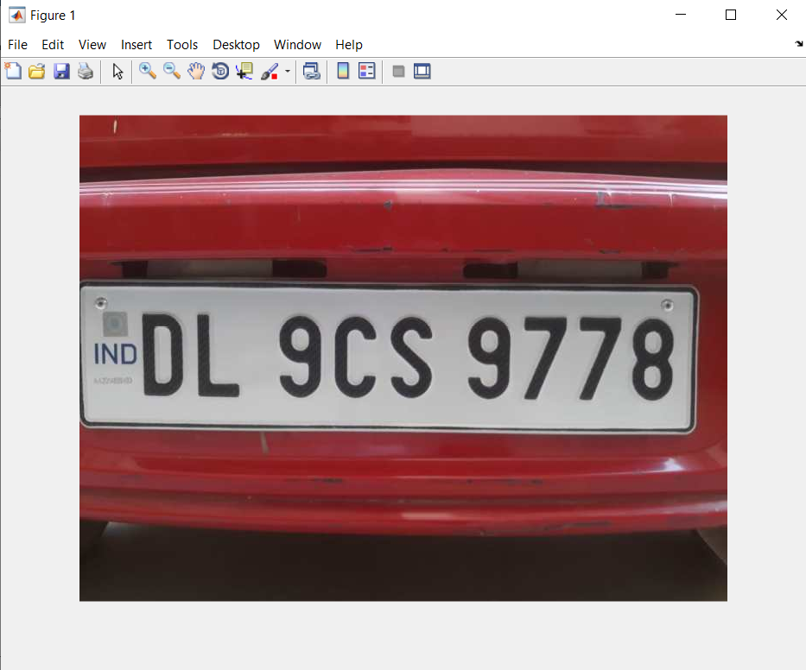

**Fig.4:** Original Image (RGB)

2. Next, the original image is converted to grayscale in order to increase the processing speeds.

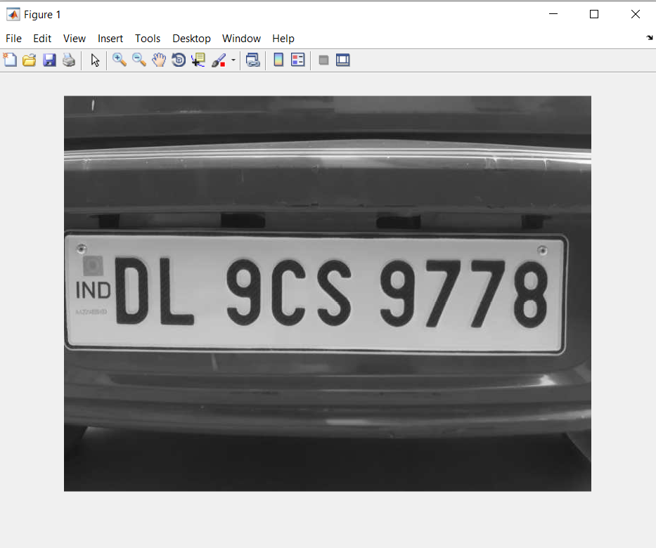

**Fig.5:** Grayscale Image

3. Conversion to grayscale alone doesn’t reduce noise so, the grayscale image is then passed through the median filter for noise reduction.

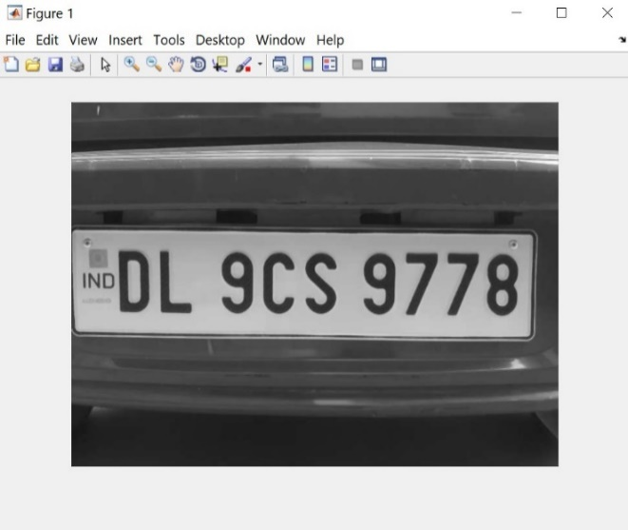

**Fig.6:** Median Filter applied on Grayscale Image

4. Now the image is converted to a binary image. It is an image which is quantised into two values representing 0 and 1 or in pixel values of 0 and 255 representing the colours black and white.

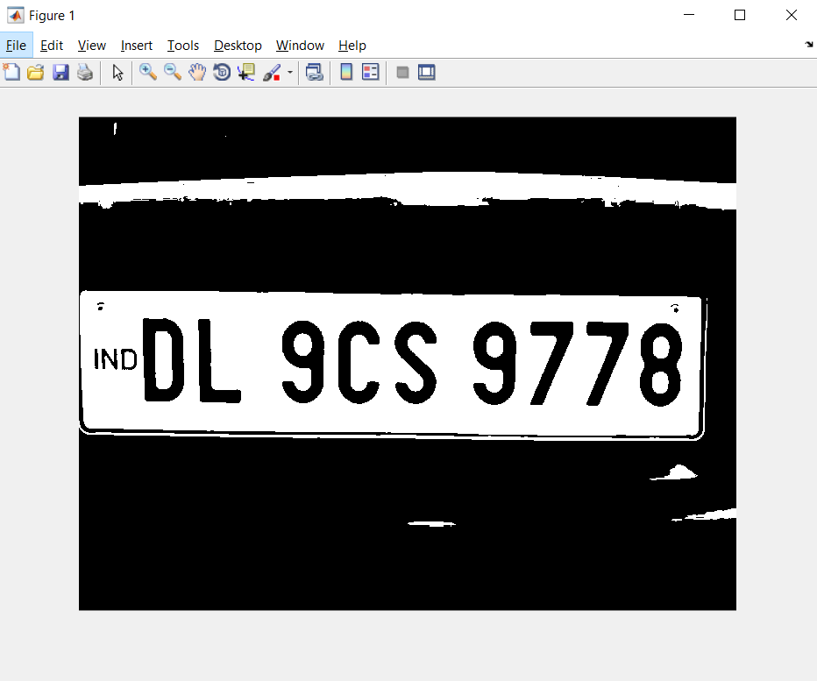

**Fig.7:** Binarized Image

5. Considering a number plate is usually rectangular or square shaped, we detect the edges of the plate using the Prewitt edge detection method.

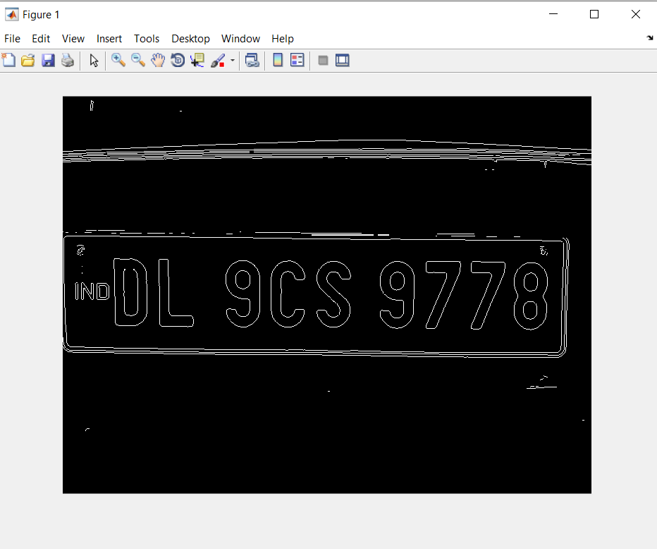

**Fig.8:** After applying Edge Detection

6. The location of the number plate is detected and the number plate is cropped out from the rest of the image.

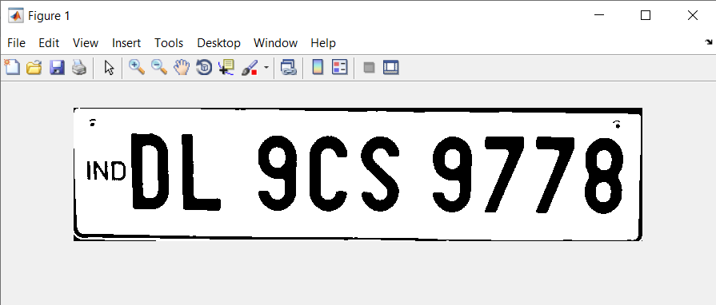

**Fig.8:** License Plate Cropped Out

7. Using the opening area operation (bwareopen( )) we remove all connected components (objects) that have fewer than 500 pixels from the binary image.

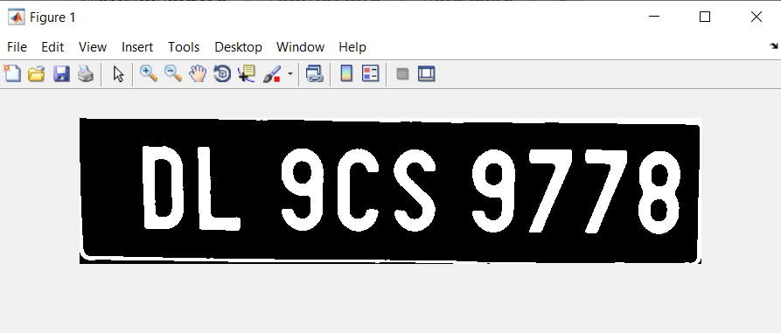

**2.1.2 Character Segmentation**

Following the above steps, the image has been pre-processed and now character segmentation can be performed on it. Segmentation is done by measuring the properties of the image using region properties of MATLAB i.e. regionprops( ) and BoundingBox. Each character in the image is enclosed within a rectangle. Thus, each character is extracted from each rectangle. After segmentation and extraction of each character, template matching is done. The segmented characters are then matched with the already designed templates using the concept of template matching.

**2.1.3 Template Matching**

Template Matching involves the comparison of each character image with each of the loaded templates, to determine the best match for each character.

The comparison is carried out by calculating the correlation coefficient of the two images. The correlation of the character image is compared to each template and the value of the maximum correlation coefficient is stored. The template having the maximum value of correlation with the character image is considered as the best match and the corresponding letter is returned.

The correlation coefficient is calculated as follows:

$$r=\frac{\sum{(x_{i}-\overline{x})(y_{i}-\overline{y})}}{\sqrt{\sum{{(x_{i}-\overline{x})}^{2}{(y_{i}-\overline{y})}^{2}}}}$$

where r = Correlation Coefficient of (x1, y1), (x2, y2), (x3, y3) … (xn, yn) observations.

= Mean of x1, x2 … xn observations,

= Mean of y1, y2 … yn observations.

2.2 FUNCTIONS USED IN ORDER OF OPERATION

**2.2.1 CreateTemplates( ):**

The main purpose of this function is to read all the templates stored in the database and store them in a format readable by MATLAB that can later be compared with the characters segmented.

Firstly, all the pre-designed templates with a .bmp extension are read into MATLAB using the imread() function and stored in similar named variables. These variables are stored in two separate arrays meant for storing alphabets and numbers respectively. Finally, these arrays are loaded into a MATLAB binary file (.MAT file) named NewTemplates which is loaded by the next function.

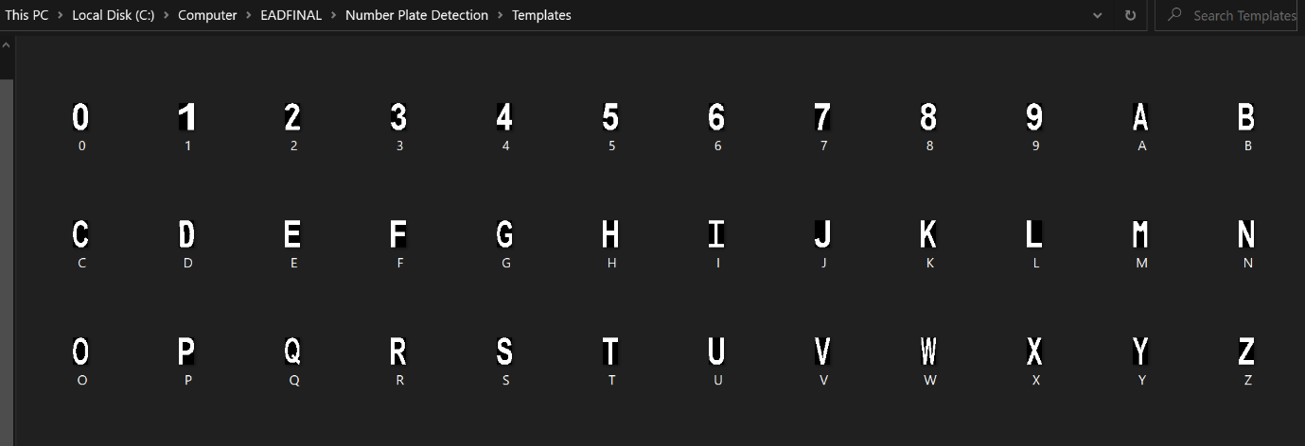

**Fig.3:** Folder containing templates with .bmp extension

**2.2.2 DetectLetters( ):**

This function is called by the main function (NumberPlateDetection( )) which passes the individual character detected through it. The DetectLetter( ) function first resizes the character image passed to it using the inbuilt function imresize() to a size comparable to the size of the templates for matching.

Next, the templates are loaded by the function for comparison using the load( ) function. The comparison is carried out by calculating the correlation coefficient of the two images using the concept of template matching, which has already been discussed extensively in section 2.1.3. The correlation operation is achieved by using the corr2() inbuilt MATLAB function.

**2.2.3 NumberPlateDetection( ):**

This is the backbone of the entire program. The NumberPlateDetection( ) function is responsible for creating necessary objects, initializing arrays, calling respective functions and most importantly, performing pre-processing on the input image. It is also responsible for compiling the database and operating the boom barrier.

Firstly the image is read using the imread() function after which the various operations involved in pre-processing are performed. After pre-processing, the location of the number plate is detected by measuring the properties of the image and using edge detection to detect the precise location of the number plate from the whole image. After this, the region of the number plate is cropped out and processed by using Bounding Boxes. Each character detected is compared with each template respectively by using Template Matching by passing it through the DetectLetters( ) function. The characters recognized are displayed in a text format along with the number plate scanned.

For having a more informative database, the date and time are displayed with the plate number detected using the pre-defined datetime( ) function. The date & time along with the plate numbers are stored in individual arrays, which are concatenated together to be displayed in the database.

2.3 DATABASE CREATION

Now that the plate number has been detected and displayed in the command window, we intend to create a database which consists of all the plate numbers, their date and time of entry and whether the vehicle was granted access or not.

To achieve this, all the plate numbers were stored in an array which was updated every time a new vehicle entered. The date and time of that particular moment are found out by using the datetime(‘now’) function. All these instances of date and time are also stored in a separate array. Both the arrays are concatenated and are displayed on the excel sheet using the xlswrite() function.

The xlswrite() function takes the following arguments:

**xlswrite(filname,matrixname,sheet,cell)**

2.4 BARRIER CONTROL

After the vehicle number plate has been detected and the vehicle has been granted access after checking in the database, a barrier is operated for security purposes which will only when a registered vehicle makes an entry.

The barrier is essentially an arm connected to an SG90 Servo Motor which is operated with a microcontroller board. In our project, we have used an Arduino Uno R3.

For using an Arduino with MATLAB, first an Arduino object was created in the NumberPlateDetection() function using the arduino() command. Following this, an object for the servo motor was also created using the servo() command. The position of the arm of boom-barrier is operated using the writePosition() function which takes two arguments, the servo motor object and the angle, whose value varies between 0 and 1 i.e. 0 and 180 degrees. While keeping the barrier closed, the value of angle is 0 and when the barrier is opened the value is 0.5, i.e., 90 degrees.

III. CONCLUSION

A Number Plate Detection cum Security System was implemented using MATLAB by using the concept of template matching. The algorithm successfully detects the location of the number plate in the image and segments the different characters present in it. Firstly, the image is acquired from the camera on which pre-processing steps are applied to make the image more suitable for segmentation. The characters are segmented by using bounding boxes and later compared to templates using template matching. The results are displayed in the command window and a database is created. Moreover, a barrier system for security purposes is also incorporated. The algorithm was tested on multiple images and an accuracy rate of around 92.22% was achieved.

Some of the common difficulties faced and scopes of improvement are:

1. Intolerant to images with very high brightness.

2. Skewed Images

3. Inaccurate results in case of images which are out of focus or where number plate isn’t clearly visible.

4. Similar results for certain characters such as “D” & “0”, “A” & “4” or “5” & “S” etc.

IV. REFERENCES

1. Nighat Naaz Ansari, Ajay Kumar Singh, “License Number Plate Recognition using Template Matching”, International Journal of Computer Trends and Technology (IJCTT) – Volume 35 Number 4- May 2016.
2. Ragini Bhat, Bijender Mehandia, “Recognition of Vehicle Number Plate Using Matlab”, International Journal of Innovative Research in Electrical, Electronics, Instrumentation And Control Engineering Vol. 2, Issue 8, August 2014
3. Ratnakar N, “Recognition of Number Plate by Using Matlab”, JETIR March 2016, Volume 3, Issue 3.
4. Narendra Singh Tomar, Prakhar Sachan, Pranav Mittal, Shivani Agarwal, “Vehicle Number Plate Detection Using Matlab”, International Research Journal of Engineering and Technology (IRJET) Volume: 05, Issue: 05, May-2018.
5. Bhawna Tiwari, Archana Sharma, Malti Gautam Singh, Bhawana Rathi, “Automatic Vehicle Number Plate Recognition System using Matlab”, IOSR Journal of Electronics and Communication Engineering (IOSR-JECE). Volume 11, Issue 4, Ver. II (Jul.-Aug .2016).
6. Shilpi Chauhan and Vishal Srivastava, “Matlab Based Vehicle Number Plate Recognition”, International Journal of Computational Intelligence Research ISSN 0973-1873 Volume 13, Number 9 (2017), pp. 2283-2288.